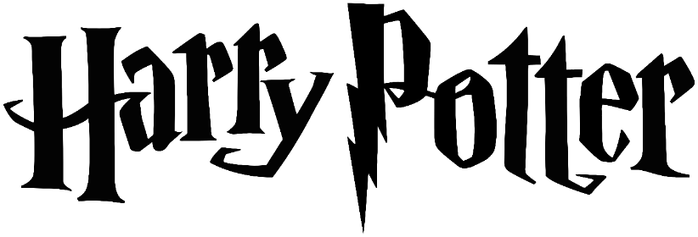
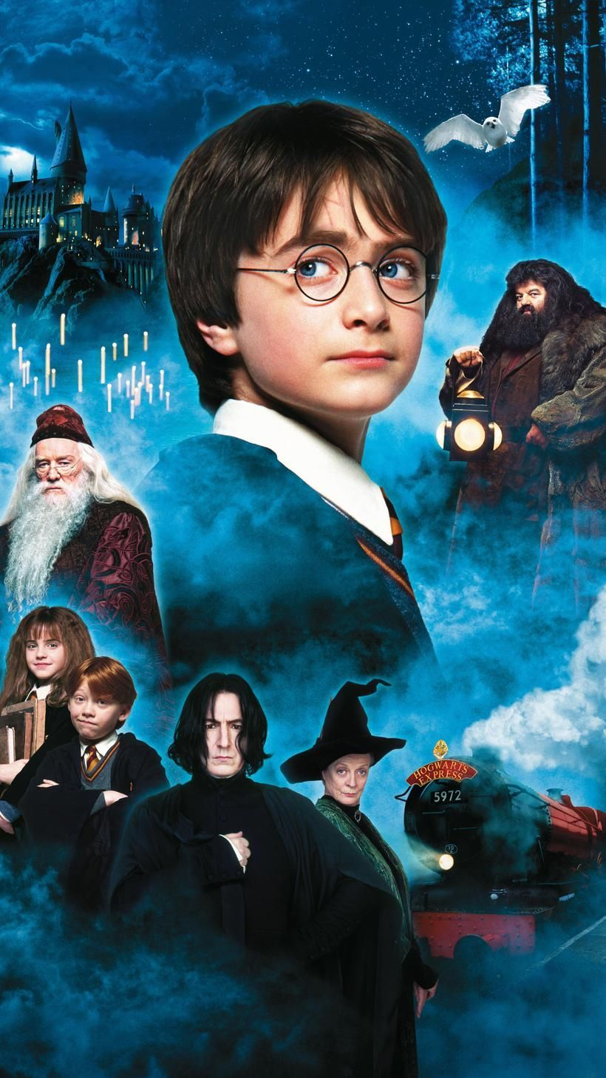

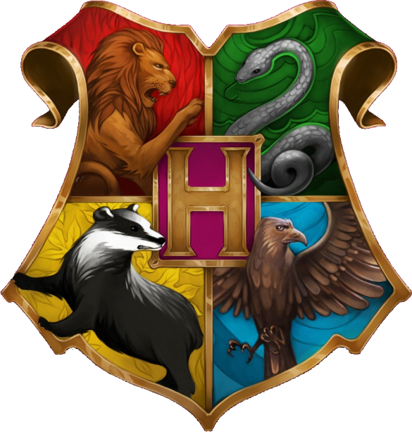

Student Name:

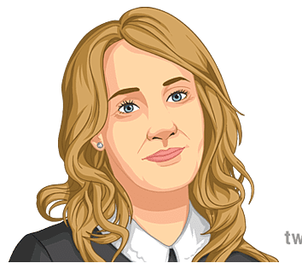
J. K Rowling
Biography

J.K. Rowling is the best-selling living author in the UK and her books are popular all over the world. Rowling has described writers such as Jane Austen and C.S. Lewis as her sources of inspiration. She was born Joanne Rowling on 31st July 1965, in Gloucestershire. She enjoyed writing fantasy stories from an early age, reading them to her younger sister. As a teenager, Rowling began studying French and Classics at Exeter University. Having graduated, she moved to London to work as a researcher for Amnesty International, an organisation which works to protect human rights around the world. She later moved to Manchester, where she worked at the Chamber of Commerce.
Name:
Joanne Rowling
Born:
31st July 1965
Place of Birth:
Gloucestershire, UK
Occupation:
Writer Author

It was in 1990, when Joanne was on a delayed train journey from Manchester to London that the idea for a series of books came into her head. During the writing of the first Harry Potter book, Joanne’s mother died, greatly affecting her writing. Rowling decided to introduce more detail about the loss of the main character’s parents as she knew how it felt. Rowling used her life as inspiration for many other ideas in the book, for example, her parents met at Kings Cross Station, which is where Harry Potter catches the train to school, and Joanne shares her birthday with Harry.

After living and working as an English teacher in Portugal, Rowling moved to Edinburgh with her daughter, who is named after one of Joanne’s favourite writers. Those early days of living in Scotland weren’t easy for Rowling - she had no job but dedicated her time to finishing her book. When the story was finally completed, it was sent to 12 different publishing houses, all of which turned it down. In 1997, the book was finally published by Bloomsbury under the name J.K. Rowling. As Joanne didn’t have a middle name, she incorporated her grandmother’s name, ‘Kathleen’ into her initials. Her real name wasn’t used as the publishers didn’t think that boys would want to read a book written by a female author. Shortly after being published, the book won its first award and proved to be hugely popular. She later released the sequel, ‘Harry Potter and the Chamber of Secrets’, followed by ‘Harry Potter and the Prisoner of Azkaban’. It was the fourth book in the series, ‘Harry Potter and the Goblet of Fire’, which broke sales records in both the UK and America. Rowling was also named Author of the Year at the 2000 British Book Awards and awarded an OBE for services to children’s literature

The final book in the series, ‘Harry Potter and the Deathly Hallows’, was released in 2007 and became the fastest-selling book in history, selling millions of copies on the first day of release. The books were made into hugely successful films and have captured the imaginations of children and adults all around the world. Since the end of the Harry Potter stories, Rowling has written other books linked to the series. She has also written stories for adults and continues to embark on other projects.
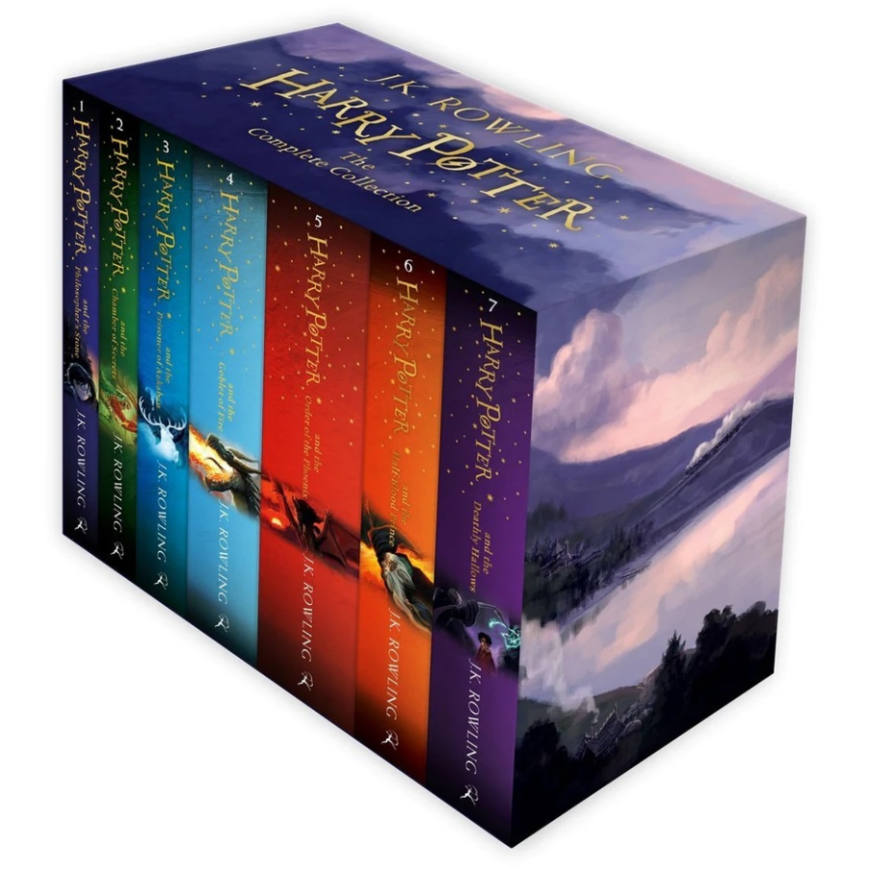
Today, original copies of ‘Harry Potter and the Philosopher’s Stone’ sell for around AUD $33 000 and the series has been translated into 65 languages.

Questions
Answers must in full sentences.
- When and where was she born?

…………………………………………………………………………………………………………………………………………………………………………………………………………………………

- Name one of Rowling’s favourite authors.

…………………………………………………………………………………………………………………………………………………………………………………………………………………………

- Which university did Joanne study at?

…………………………………………………………………………………………………………………………………………………………………………………………………………………………

- Explain why she moved to London

………………………………………………………………………………………………………………………………………………………………………………………………………………………………………………………………………………………………………………………………………

- Where did Joanne come up with the idea for the Harry Potter series?

………………………………………………………………………………………………………………………………………………………………………………………………………………………………………………………………………………………………………………………………………

- Can you explain how the death of her own mother affected her writing

………………………………………………………………………………………………………………………………………………………………………………………………………………………………………………………………………………………………………………………………………

- Give two other ways in which she has used her own life experiences in the Harry Potter books

……………………………………………………………………………………………………………………………………………………………………………………………………………………………………………………………………………………………………………………………………………………………………………………………………………………………………………………

- What did the publishers think about Joanne’s full name being printed on her books?

………………………………………………………………………………………………………………………………………………………………………………………………………………………………………………………………………………………………………………………………………

- What could one other the original copies of ‘Harry Potter and the Philosopher’s Stone’ sell for?

…………………………………………………………………………………………………………………………………………………………………………………………………………………………

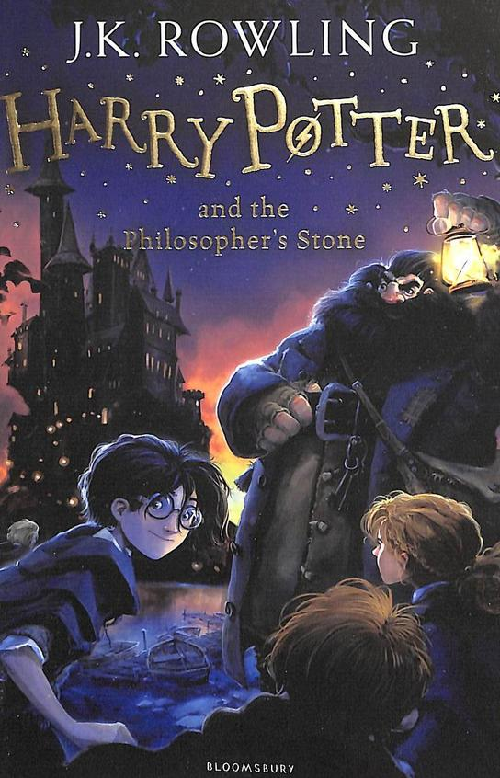
Book Review

Book Title:
…………………………………………………………………………………………………………………………………………
Publisher:
…………………………………………………………………..
Author
…………………………………………………………………..
Date of first publication:
…………………………………………………………………..
Amount of copies sold:
……………………………………………………………………

What is the story about?
…………………………………………………………………………………………………………………………………………………………………………………………………………………………………………………………………………………………………………………………………………………………………………………………………………………………………………………………………………………………………………

Who is the main characters in the book?
………………………………………………………………………………………………………………………………………………………………………………………………………………………………………………………………………………………………………………………………………………………………………………………………………………………………………………………………………………………………………………………………………………………………………………………………………………………………………………………………………………………………………………………………………………………………

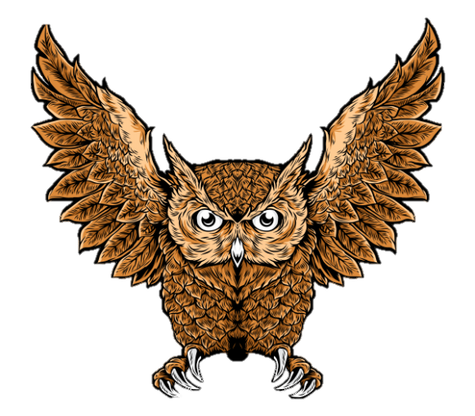
Read the following story to answer the questions

Harry Potter and the Philosophers Sone

The Boy Who Lived - Chapter One

Who lives at Privet Drive and what number is the house?
Mr and Mrs Dursley of 4 Privet Drive and their son Dudley

What was Mr Dursley’s job?
He worked as a director at a firm called Grunnings making drills

How does J. K Rowling describe Mr Dirsley?
Big beefy man with any neck and a large mustash

How does J.K Rowling describe Mrs Dirsley
Thin and blonde she a lot of neck. always spying on the nabours

What was the Dursley’s son called?
Dudley

What did Mr Dursley see when leaving for work?
A cat reading a map

What was the main topic on the evening news Mr Dursley was watching?
Large owl sightings moving in all directions and professionals unable to explain

Describe the man that suddenly appeared on the corner of Privet Drive
Wearing a purple cloak, half moon glasses, high healed buckled boots, tall thin and vary old with long silverhair blue eyes bright and sparked, long crucked nose

What was the man of the name on Privet Drive?
Albous Dumbledore

What was the name of the item he took out of his pocket and what did it do
It looked like a cigarette lighter (called he put outer) he clicked it and the closes light went out.

How many lights went out on Privet Drive?
12

What did Dumbledore call the cat?
Professor McGonagall

How does JK Rowling describe Professor McGonagall?
Hair in a tight bun, black hair, square glasses, emerald cloak,

What is the real name of “You know Who”?
Voldemort

What sweets did Dumbledore eat?
Sherbert lemon sweets

What was the piece of jewellery Dumbledore had in his pocket?
Gold watch with 12 hands with planets moving around the edge

Why was Dumbledore at Privet Drive?
To bring Harry to like with the Dursley

What did Hagrid travel on to private Drive?
A Motorbike

How does JK Rowling describe Hagrid?
Twice as tall as a normal man, 5 times a wide, wild, long bushy hair covering most of his face, beard, hands the size of dustbin lids, leather shoes like baby dolphins, muscular arms,

Who’s motorbike was it Hagrid travelled on?
Young serious black

how was harry woken up?
Mrs Dursleys scream when she found him on the doorstep

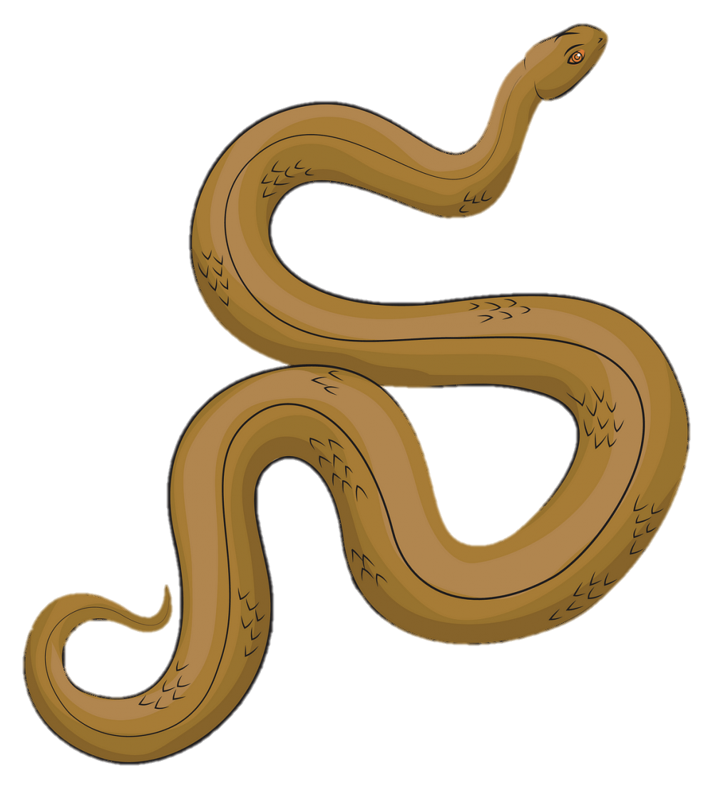
The Vanishing Glass - Chapter Two

Read the following story to answer the questions

Harry Potter and the Philosophers Sone

How many years had past from Chapter One?
10

Who’s Birthday was it?
Dudley

Where is Harry sleep?
Under the stairs

How does J K Rowling describe Harry?
Black hair, very fast, small and skinny, wears old clothes of Dudley, Bright green eyes nobble knees, thin face, wore round shaped classes covered in Sellotape, scar shaped like a bolt of lightning. Hair all over the place.

How does J K Rowling describe Dudley?
Large pink face with not much neck, small watery blue eyes, Thick blonde hair, pig in a wig as harry would say

How many presents did Dudley get for his birthday?
39 presents

Who would Harry go and stay with on Dudley’s Birthday
Mrs Fig

Were did they go for Dudley’s birthday?
The zoo

What did Dudley want to see at the zoo?
Snake

What did the snake do to Harry?
Winked at Harry and had a conversation

What happened to the snake’s enclosure at the zoo?
The glass disappeared and the snake got out

what does harry always dream of?
A flying motorbike,

Harry Potter and the Philosophers Sone

Read the following story to answer the questions

The Letter from No One - Chapter Three

What secondary school was Harry going to after the school holidays?
Stonewall High

What was Mrs Dudley doing in the kitchen sink?
Dying old dudley clothes grey for harry new school uniform

How does JK Rowling describe the letter Harry received?
Thick and heavy yellow parchment paper, address written in Emerald green ink, no stamp, on back a purple was seal with a Lion, eagle, Badger, Snake surrounding a large letter “H”

Why did Harry get given Dudley’s second bedroom following receiving the letter?
They was worried the house was being watched as they should know he slept under the stairs, they was worried

How did Dudley respond to Harry having his other room?
bailing at his mum for him to get out of his room as he needed it and wanted it back. Screamed wacked his dad wth a spoon, kicked his mum, and thrown th tortoise through the greenhouse

How did the second letter change?
The address change to state the smallest bedroom instead of under the stairs.

What did Mr Dursley do to stop harry getting a 3rd letter?
He slept in a sleeping bag at the front door

What did Mr Dursley do to stop a 4th letter coming?
He stayed off work and nailed the letterbox closed

By Friday how many letters had been deliver
12

List the ways letters was delivered?
Letterbox
Under the door
Through the window
Down the chimney
On Tuesday how old would Harry be?
11

Letters to Harry Potter

In Chapter two how did the letters change whilst being sent to Harry?

Write the letter address labels in order of sequences as described in the book

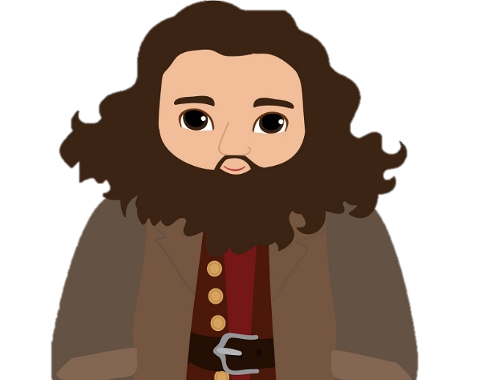
Read the following story to answer the questions

The Keeper of Keys - Chapter Four

Harry Potter and the Philosophers Sone

What did Hagrid give Harry for his birthday?
Sticky chocolate cake with green happy birthday icing

What was the address of the final letter Harry received given to him by Hagrid
Mr H Potter
the floor
hut on the rock
the sea

What date was Harry set to start school at Hogwarts
1st September

How old was Harry when Voldemort killed his parents and in what festive period?
Halloween - he was 1year old

How long will Harry spend at Hogwarts
7 years

Why is Hagrid not allowed to do magic
He was expelled from Hogwarts in his 3rd year and had his wand snapped

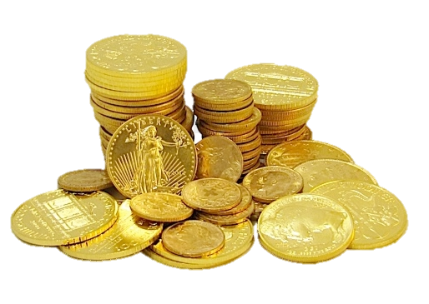
Harry Potter and the Philosophers Sone

Read the following story to answer the questions

Diagon Alley - Chapter Five

What was the bronze coins called used to pay the owl for delivering the newspaper
Knut

What is the bank of wizards called and who runs it
Gringotts and goblins run it

Where is the bank located
London

What is the role of the Minister of Magic
To stop the muggles getting the knowledge of wizards and wizardry

What was the shop Harry and Hagrid entered to get to Diagon Alley
The Leak caldron

What was the first teacher Harry Met on his journey?
Professor Quirrell

What volt was Hagrid tasked to visit by Dumbledore at Gringotts
713

Who was the first boy Harry Met at Diagon Alley
Draco Malfoy

What’s the wizards favourite sport
Quidditch

What shops did Harry visited at Diagon Alley?
Madam Malkin’s robes for all occasions
Flourish and Blotts
Apothecary
Eeylops Owl Emporium
Ollivanders

What was the wand Harry chose
Holly and phoenix feather 11inches

What was on Harry’s school list of items – Write what the list stated
Hogwarts School of Witchcraft and Wizardry

Uniform
First-year students will require:
- Three sets of plain work robes (black)
- One plain pointed hat (black) for day wear
- One pair of protective gloves (dragon hide or similar)
- One winter cloak (black, with silver fastenings)
Please note that all pupil’s clothes should carry name tags.

SET BOOKS
all students should have a copy of each of the following:
- The Standard Book of Spells (Grade 1) by Miranda Goshawk
- A History of Magic by Bathilda Bagshot
- A Beginner’s Guide to Transfiguration by Emeric Switch
- One Thousand Magical Herbs and Fungi by Phylida Spore
- Magical Drafts and Potions by Arenius Jigger
- Fantastic Beasts and Where to Find Them by Newt Scamander
- The Dark Forces: A Guide to Self-Protection by Quentin Trimble

OTHER EQUIPMENT
- 1 wand
- 1 cauldron (pewter, standard size 2)
- 1 set glass or crystal phials
- 1 telescope
- 1 set brass scales
Students may also bring an owl or a rate or a toad
Parents are reminded that first years are not allowed their own broomstick
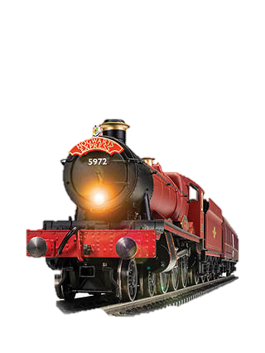
Read the following story to answer the questions

The Journey from Platform Nine and Three-Quarters
Chapter Six

Harry Potter and the Philosophers Sone

What time was Harry’s train set to leave, from what station and which platform
Kings cross station – 11am at platform 9 ¾

What was the names of the boys Harry met at the platform?
Fred, George, Ron, Percy

Who did Harry sit with on the journey to Hogwarts
Ron Weasley, Hermione Granger

What was Ron’s pet he brought to Hogwarts
Scabrous the rat

What did Harry buy from the train trolley
Bertie Botts every flavoured beans
Drooble’s best blowing gum
Chocolate frogs
Pumpkin patsy
Cauldron cakes
Liquorice wands

What wizard did Harry get on his Chocolate Frog card
Albus Dumbledore
Morgana
Hengist of Woodcroft
Alberic Grunnion
Salazar
Paracelsus
Merlin
Cliodna

What house did did Ron not want to be place within?
Slytherin

Who was the three boys that came to see Harry in the Train cabin
Draco Malfoy
Vincent Crabbe
Gregory Goyle

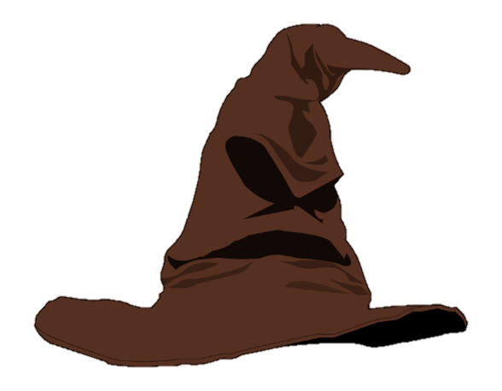
Read the following story to answer the questions

Harry Potter and the Philosophers Sone

The Sorting Hat - Chapter Seven

What are the four houses the sorting hat can choose
Gryffindor · Hufflepuff · Ravenclaw · Slytherin

What house did Harry not want to to be in?
Slytherin

What was the strange item on the banquet table
Mint humbugs

Who was the
Professor Snap

Start of term notices given by Dumbledore
The forest is forbidden to all students
No magic in the corridors
Quidditch trials to be held in the second term
3rd floor corridor right hand side is out of bounds

What was the password to enter into the common room
Caput Draconis

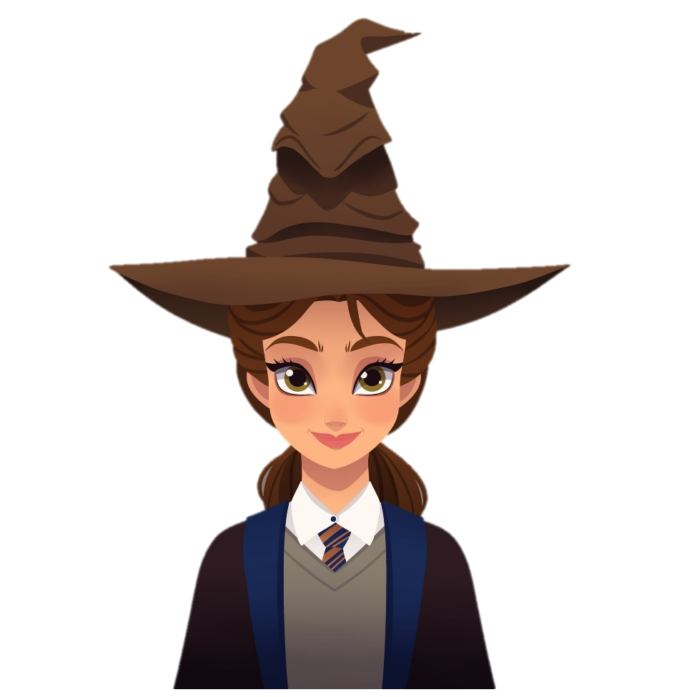
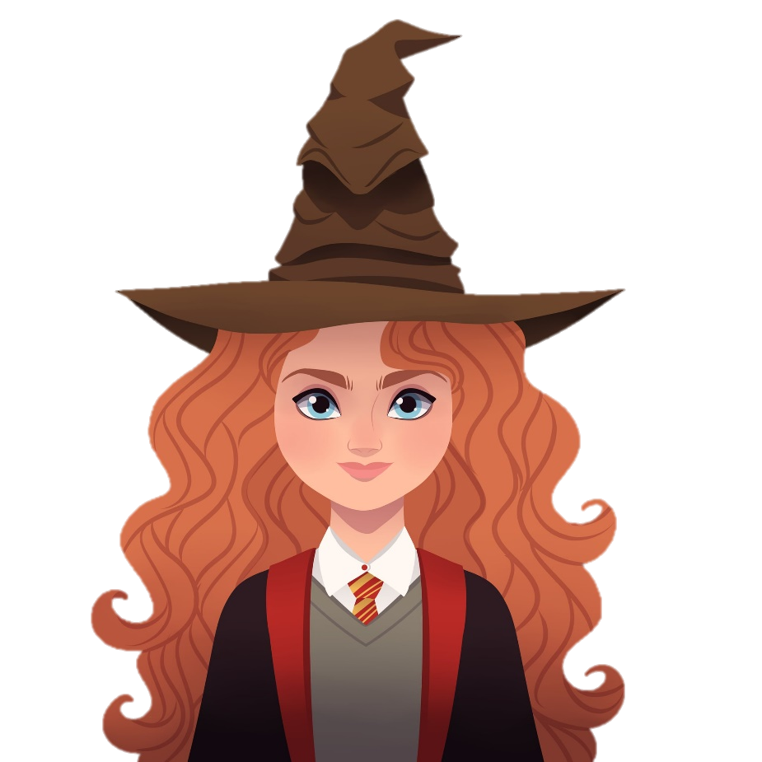
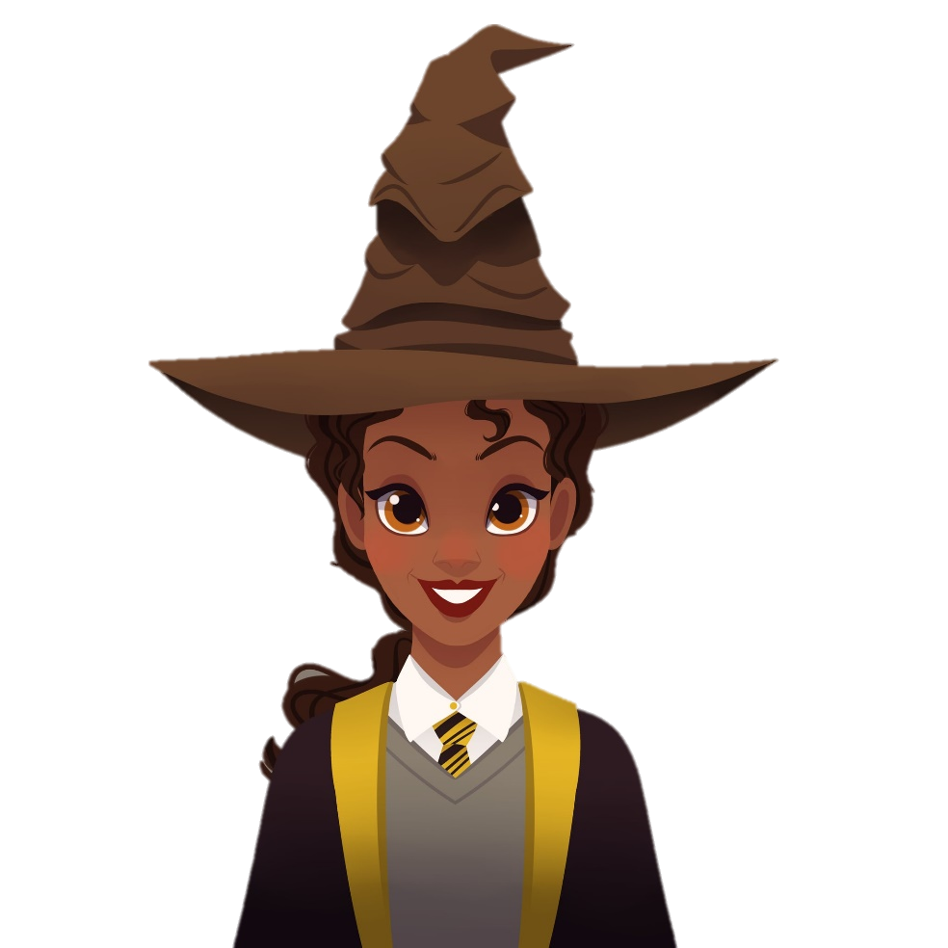

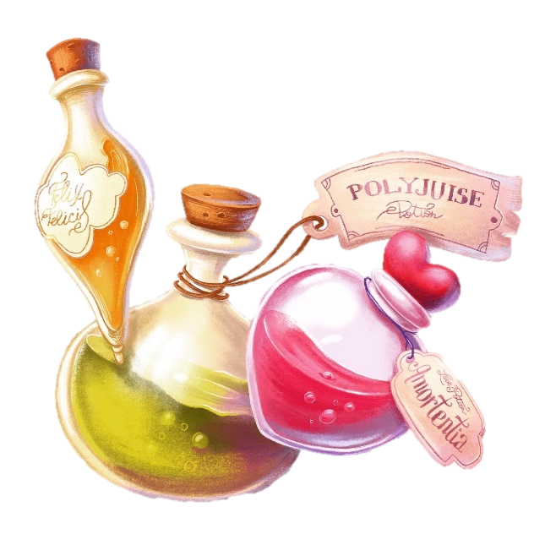
The Potions Master- Chapter Eight

Read the following story to answer the questions

Harry Potter and the Philosophers Sone

How many staircases are there in Hogwarts
142

What would Peeves the poltergeist do to students at Hogwarts
Drop wastepaper bin on your head
Pull rugs from under you
Pelt you with chalk
Grab your noes

What was Argus Filch’s cat called
Mrs Norris

When do students have to study the nights sky
Ever Wednesday at midnight

Who teaches herbology at Hogwarts
Processor sprout

Who is the Charms professor at Hogwarts
Professor Flitwick

Who is the transfiguration teacher
Professor McGonagall

Where was Professor Snapes lessons take place within Hogwarts
The dungeons

What was the book Harry was supposed to study for Processor Snapes lesson
One Thousand Magical Herbs and Fungi by Phylida Spore

What was the position students was practicing in Professor Snapes lesson
Boils

What was the name of Hagrid’s dog
Fangs

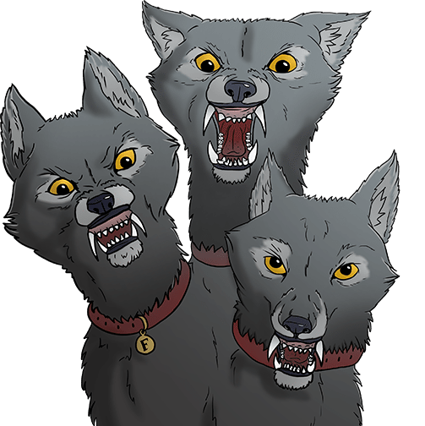
Harry Potter and the Philosophers Sone

Read the following story to answer the questions

The Midnight Duel - Chapter Nine

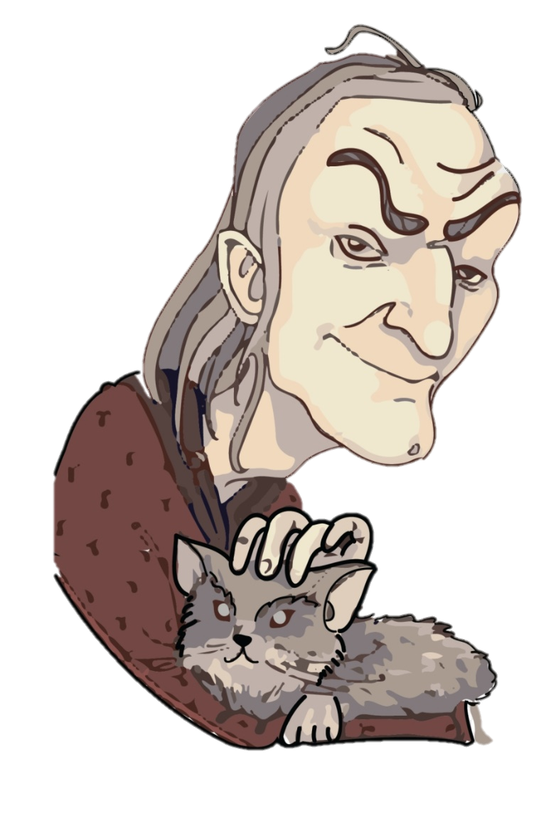
What day was flying lessons
Thursdays

Who was the teacher for the flying lesson
Madam Hooch

Where did Processor McGonigal take Harry
To Professor Flitwick class to get 5th Year - Wood

Why did Professor McGonigal introduce Harry to Wood
To make Harry the seeker in the quidditch team

Were was the Midnight Duel to take place
The trophy room

Why did Hermione have to go to the Midnight Duel
The fat lady had gone on a night-time visit and she was locked out of the tower

Where did Harry and others meet Peeves
The Charms corridor

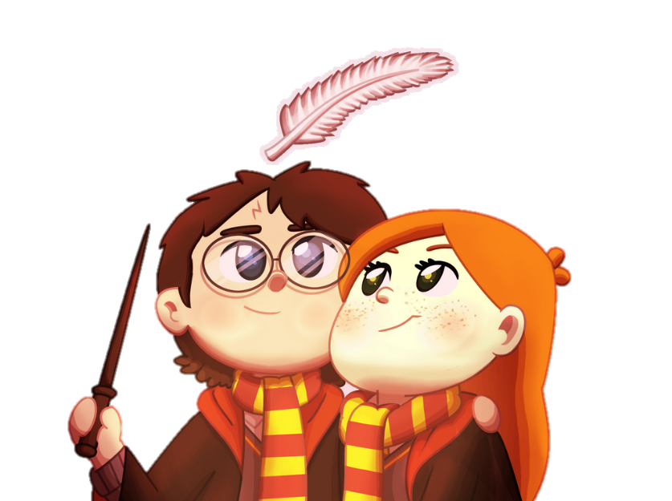
Hallowe’en - Chapter Ten

Read the following story to answer the questions

Harry Potter and the Philosophers Sone

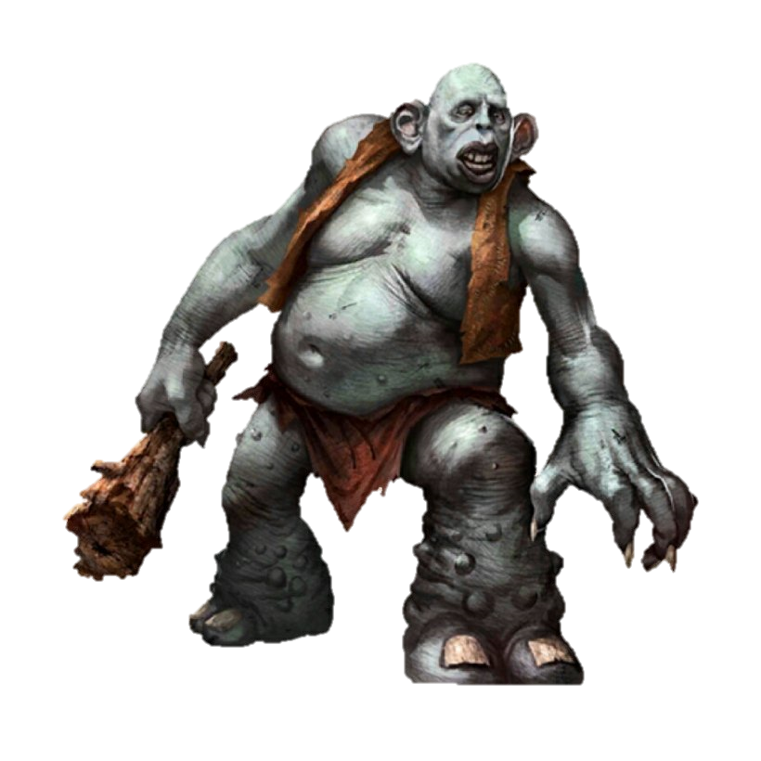
What was the large parcel given by the owls to Harry
Nimbus 2000 broomstick

From the description given draw the Nimbus 2000
How many Balls are within a Quidditch game and what are names of the balls
Golden Snitch
Quaffle
2x Bludgers

Why did Harry and Ron not go to their dorm
They went to warn Hermione about the troll

What did Harry do to the troll
Harry jumped on the trolls back and stuck his wond up its nose

what spell did Ron use to defeat the troll
He used the spell wingardium leviosa

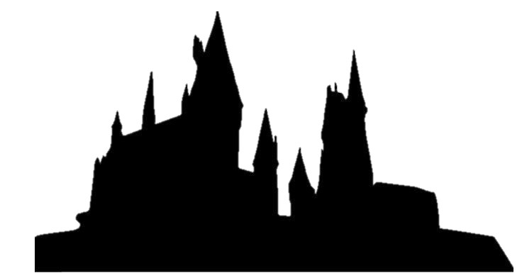

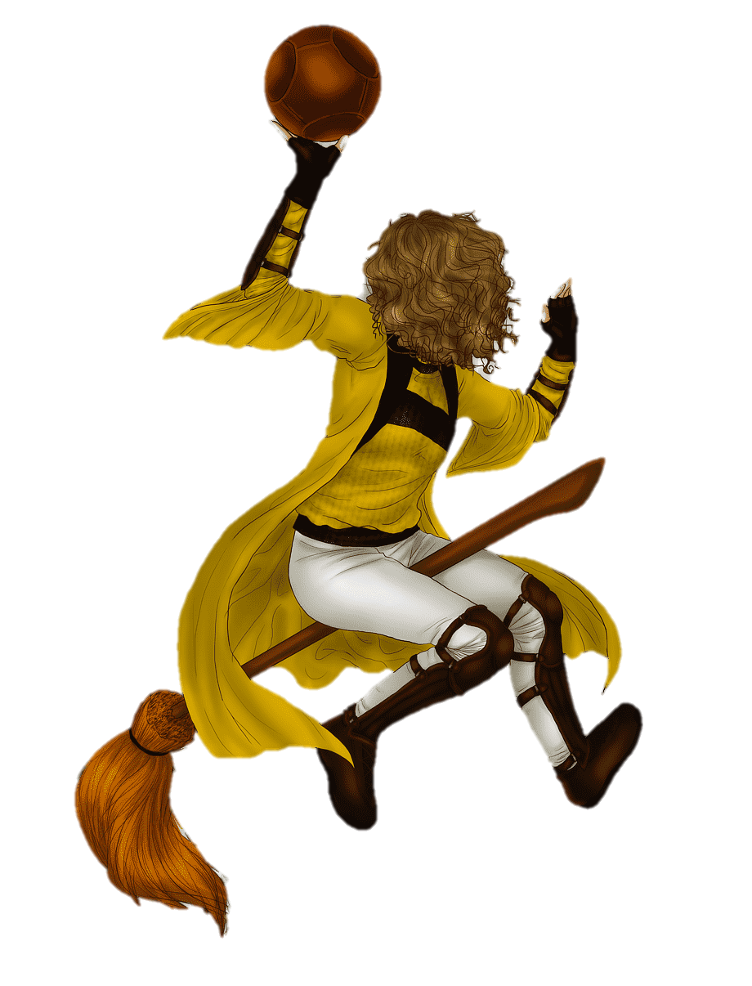
Quidditch- Chapter Eleven

Harry Potter and the Philosophers Sone

Read the following story to answer the questions

In which month does Quidditch tournament begin
November

What book had Harry been reading to help him with Quidditch
Quidditch through the ages

What did Hermione do to keep Harry, Ron and Hermione
A blue fire in a jam jar to keep them warn

