Withdrawal Form for Alternative Provision

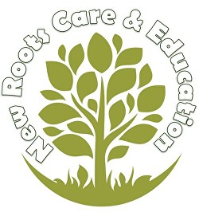

Please send to enquiry@nrce.co.uk when completed

New Roots Care & Education requires a term notice of withdrawal. This can be accepted with an early exit with the discussion with the head of the organisation

Learner Name: | DOB:
School: | Year:
Provision Details to be withdrawn from:

From what date:

Reason for withdrawal:
Authorised by: | Date:

